Digital Logic Design Laboratory

Lab 4

Multiplexers

Full name: Đỗ Minh Duy

Student number: ………………………………….

Class: ……………………………………………….......

Date: 10/5/2024

# I. Objectives

In this laboratory, students will study:

- Understand and design a multiplexer.

- Use a multiplexer and design/implement a circuit based on a function definition.

- Design combinational circuits using MUX.

# II. Procedure

1. Design multiplexer using logic gates

a. Design 2-to-1 multiplexer using logic gates:

A 2-to-1 multiplexer has I0 and I1 are the two inputs, S is the selector input, and Y is the output. When S = 0 then Y = I0 but when S = 1 then Y = I1. The Figure 1 shows the illustration of MUX 2-1.

MUX 2- 1

I0

I1

S

Y

Figure 1. The illustration of MUX 2-1.

Built the truth table:

|  |  |  |  |
| --- | --- | --- | --- |
| Input | | | Output |
| S­ | I0 | I1 | Y |
| 0 | 0 | 0 | 0 |
| 0 | 0 | 1 | 0 |
| 0 | 1 | 0 | 1 |
| 0 | 1 | 1 | 1 |
| 1 | 0 | 0 | 0 |
| 1 | 0 | 1 | 1 |
| 1 | 1 | 0 | 0 |
| 1 | 1 | 1 | 1 |

The expressions:

Y = S’I0I1’ + S’I0I1 + SI0’I1 + SI0I1

= S’ I0 (I1’+ I1) + S I1 (I0’+ I0)

= SI1 + S’I0

Implement the circuit via simulation software and paste the result in here

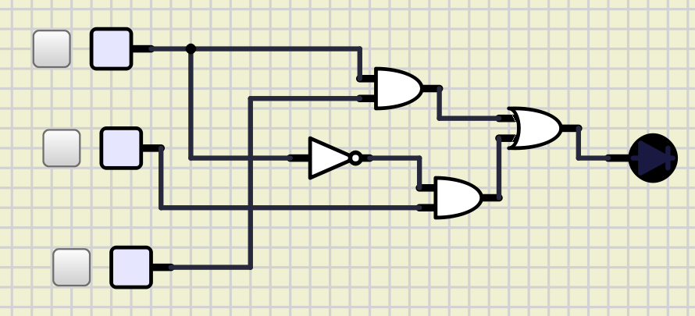

Make comment on the results

The output Y is based on the input S and I0 andI1

b. Design 4-to-1 MUX using logic gates.

Build the circuit. The inputs S0, S1, I0, I1, I2, I3 are driven by 6 switches.

|  |  |  |
| --- | --- | --- |
| Input | | Output |
| S0­ | S1 | Y |
| 0 | 0 | I0 |
| 0 | 1 | I1 |
| 1 | 0 | I2 |
| 1 | 1 | I3 |

The expressions:

Y = S1’S0’I0 + S1S0’I1 + S1’S0I2 + S1S0I3

Implement the circuit via simulation software and paste the result in here

Make comment on the results

The output Y is based on the input S0, S1, I0, I1, I2, I3 when turn on the I0 the light is on.

c. Design 4-to-1 MUX using 3 MUX 2-1.

Implement the circuit via simulation software and paste the result in here

Make comment on the results

The results of designing a 4-to-1 MUX using three 2-to-1 MUXs are as expected. The truth table correctly represents the functionality of a 4-to-1 MUX, where the combination of the selection lines S1 and S0 determine which input (I0, I1, I2, I3) is passed to the output.

2. Investigate IC 8-to-1 Multiplexer (74HC151)

Construct the circuit as below:

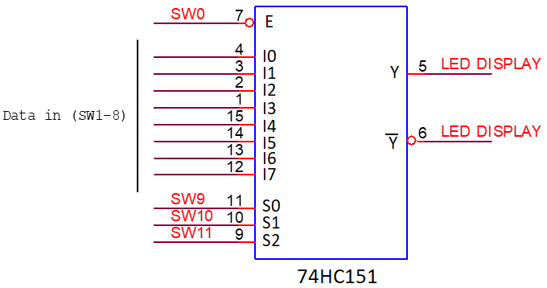

Figure 2. IC 8-to-1 Multiplexer (74HC151)

- 2 outputs are connected by using LEDs.

- The inputs are controlled by switches.

- Observe the results and fulfill the truth table

|  |  |  |  |  |  |
| --- | --- | --- | --- | --- | --- |
| INPUT | | | | OUTPUT | |
| S2 | S1 | S0 | E | Y | $$\overline{\text{Y}}$$ |
| X | X | X | 1 | 0 | 1 |
| 0 | 0 | 0 | 0 | I0 | I7 |
| 0 | 0 | 1 | 0 | I1 | I6 |
| 0 | 1 | 0 | 0 | I2 | I5 |
| 0 | 1 | 1 | 0 | I3 | I4 |
| 1 | 0 | 0 | 0 | I4 | I3 |
| 1 | 0 | 1 | 0 | I5 | I2 |
| 1 | 1 | 0 | 0 | I6 | I1 |
| 1 | 1 | 1 | 0 | I7 | I0 |

Implement the circuit via simulation software and paste the result in here

Briefly describe the operation of the IC

An 8-to-1 multiplexer consists of eight data inputs I0 through I7, three input select lines S0 through S2 and a single output line Y. Depending on the select lines combinations, multiplexer selects the inputs.

3. Implement the 3-variable logic function using 74HC151

- Implement Boolean expression using IC 74HC151.

- The data inputs S0, S1, S2 are connected to switches.

- Implement the circuit and verify the truth table

a. $f(S_{2},S_{1},S_{0}) = \sum_{S_{2}S_{1}S_{0}}^{ }{(1,3,5,6)}$

Implement the circuit via simulation software and paste the result in here

Make comment on the results

b. $f(S_{2},S_{1},S_{0}) = \sum_{S_{2}S_{1}S_{0}}^{ }{(2,3,4,7)}$

Implement the circuit via simulation software and paste the result in here

Make comment on the results

4. Implement the 4-variable logic function using 74HC151

a. Implement the connected diagram using 74HC151.

Construct the circuit as Figure 3:

Change the logic levels of the inputs C, B, A.

Observe and make comment on the results.

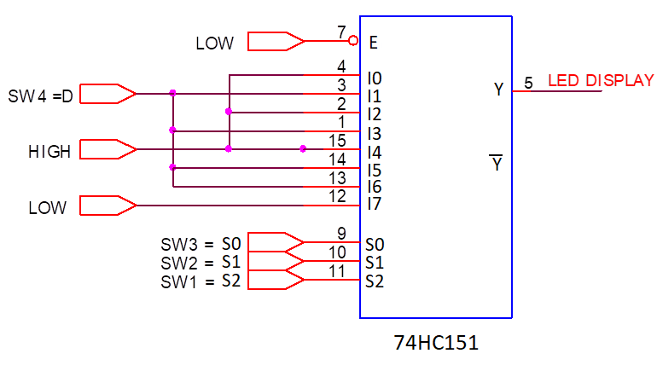

Implement the circuit via simulation software and paste the result in here

Write down the expression of $f(D,S_{2},S_{1},S_{0})$ and make comments on the results

Y = $S_{2}'S_{1}'S_{0}'$ + $S_{2}'S_{1}S_{0}'$ + $S_{2}S_{1}'S_{0}'$ + ${DS}_{2}'S_{1}'S_{0}$ + ${DS}_{2}'S_{1}S_{0}$ + ${DS}_{2}S_{1}'S_{0}$ + ${DS}_{2}S_{1}S_{0}'$

b. Implement logic expression using 74HC151

Given the expression:

$$f\left(D,S_{2},S_{1},S_{0}\right)=D S_{2} \overline{S_{1}} S_{0}+S_{2} S_{1} \overline{S_{0}}+\overline{S_{2}} S_{1} S_{0}+\overline{D}\overline{S_{2}} \overline{S_{1}}S_{0}$$

Draw the block diagram

Implement the circuit via simulation software and paste the result in here

Make comments on the results

The 74HC151 is an 8-bit multiplexer with eight binary inputs (I0 to I7), three select

inputs (S0 to S2) and an enabled input (E). One of the eight binary inputs is selected by

the select inputs and routed to the complementary outputs (Y and Y). A LOW on E

forces the output Y HIGH.